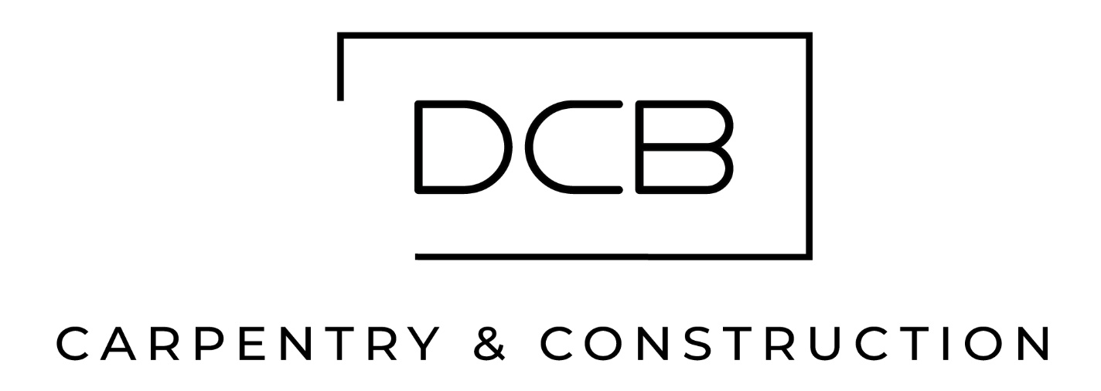
Capability Statement

Company Overview
Company Name: DCB Carpentry & Construction Pty Ltd
Founded: 2015
Head Office: Ocean Reef, WA 6027
Website: www.dcbcarpentry.com.au
Primary Contact:
Darren Bergin, Director
darren.bergin@dcbcarpentry.com 0420 794 468
About Us:
DCB Carpentry & Construction is a highly experienced, WA-based construction company known for delivering tailored solutions across mining, civil, modular, commercial, and residential projects. With a strong presence in remote and regional areas, DCB is committed to excellence in execution, health and safety, and customer satisfaction.

Core Capabilities
DCB provides a comprehensive suite of construction services, including:
- Carpentry & Joinery: For modular, commercial, residential, and mining infrastructure.
- Civil Construction: Concrete works, earthworks, pit & pipe, drainage, and stormwater systems.
- Plumbing Services: Including licensed plumbing for remote and on-site installations.
- Engineering, Drafting & Design: End-to-end support for planning and execution.
- Steel Structures: Supply, install, and fit-out of site-built steel buildings.

Key Differentiators
- Remote Project Expertise: Extensive experience in remote and challenging environments, delivering solutions under complex logistical and environmental conditions.
- Integrated Service Delivery: From design to handover, DCB manages all phases of construction, ensuring seamless coordination and accountability.
- Client-Centric Approach: Clear, proactive communication and tailored solutions ensure that clients’ goals are always front and centre.
- Agility & Versatility: DCB is known for flexibility and the ability to adapt to changing project demands — a trusted partner across sectors.
- Proven Safety Record: Strong focus on HSE, with all projects delivered under rigorous safety standards.
- Diverse Sector Experience: Successful delivery across mining, resources, commercial, government housing, education, and private developments.

Project Highlights

Mardie Salt Mine Camp

Scope: Complete site carpentry works for 400-man camp in the Pilbara.

Outcome: DCB’s involvement ensured high standards of workmanship, timely handover, and seamless integration with other site contractors under collaborative management.

Greenbushes Lithium Mine Camp

Scope: Installation of complete mining camp including modern designed dining hall.

Outcome: DCB’s involvement ensured the safe, accurate, and high-quality integration of all modular infrastructure on-site. The finished works enhanced functionality, weather protection, and comfort across the camp, while the addition of EV infrastructure and communal shade features aligned with modern sustainability and workforce amenity expectations.

Tampia Gold Camp - Narembeen
Scope: Installation of 120-man camp including site structures, concrete, and earthworks.
Outcome: Delivered on time and to specification; fully functional and integrated site supporting operational readiness.

West Musgrave Mining Camp
Scope: Setout, rigging, dogging, and installation of 28-floor modular buildings; defect rectification.
Outcome: High-quality, zero-incident completion boosted site morale and readiness.

Carrapateena Camp – Facilities Install
Scope: Installation of kitchens, recreation rooms, and essential camp facilities.
Outcome: Significantly improved living standards, comfort, and productivity for on-site teams.

Piara Waters Lifestyle Village (300+ Modular Homes)
Scope: Modular home builds with decking, carports, and facades for over-55s resort.
Outcome: Delivered high-quality, attractive, and functional housing to enhance community living.

Department of Communities Housing
Scope: Full home builds including foundation to finish, fencing, landscaping, and painting.
Outcome: Delivered durable, liveable homes to strict quality standards, supporting WA community development initiatives.
These projects represent just a portion of DCB’s extensive and diverse project portfolio.

Certifications & Licences
DCB's team holds a comprehensive range of industry certifications and licences, including:
- Trade Qualifications (Carpentry, Joinery, Plumbing)
- High-Risk Work Licences (Rigging, Dogging, EWP, HRWL LF)
- Earthmoving & Plant Operation (Excavator, Skid Steer, Telehandler, Roller, Articulated Haul Truck)
- Safety Certifications (Working at Heights, Confined Spaces, Section 44, First Aid)
- Concrete work, Formwork and Steel Fixing Accreditation

Key Personnel

Darren Bergin – Director & Founder
Over 25 years’ experience across mining, commercial and residential sectors. Specialist in carpentry, joinery, rigging, and project leadership. Hands-on approach ensures exceptional craftsmanship and performance on every project.

Mathew Dolbel – Project Coordinator
Expert in project delivery across diverse sectors. Known for efficient scheduling, stakeholder coordination, and cost control.

James Byrne – Project Supervisor (Site)
DCB's longest-serving employee with 20+ years’ experience. Skilled in managing large-scale construction with a strong focus on safety, quality, and team leadership.

Tyson Castley – Civil Supervisor
Experienced across concrete and earthworks. Skilled in leading civil teams on complex mining and resource projects.

Fiona Burns – Executive Administrator
Key contributor to business operations, document control, and client liaison. Ensures back-office efficiency and project support.

Strategic Partnerships
DCB maintains strong, long-term relationships with WA-based suppliers and subcontractors in steel fabrication, landscaping, concreting, powder coating, and feature construction — ensuring reliability and quality across all projects.

Social Responsibility
- Support for local communities – wherever possible DCB strives to use local contractors, suppliers and labour.
- Apprenticeships – DCB employs self-indentured apprentices, developing future ..

Let’s Build Something Exceptional
DCB Carpentry & Construction brings experience, versatility, and reliability to every project — from remote mining camps to community infrastructure. If you're looking for a trusted, agile construction partner capable of delivering high-quality outcomes in any environment, DCB is ready to deliver.
Contact:
Darren Bergin
darren.bergin@dcbcarpentry.com
0420 794 468
www.dcbcarpentry.com.au

